Sketch

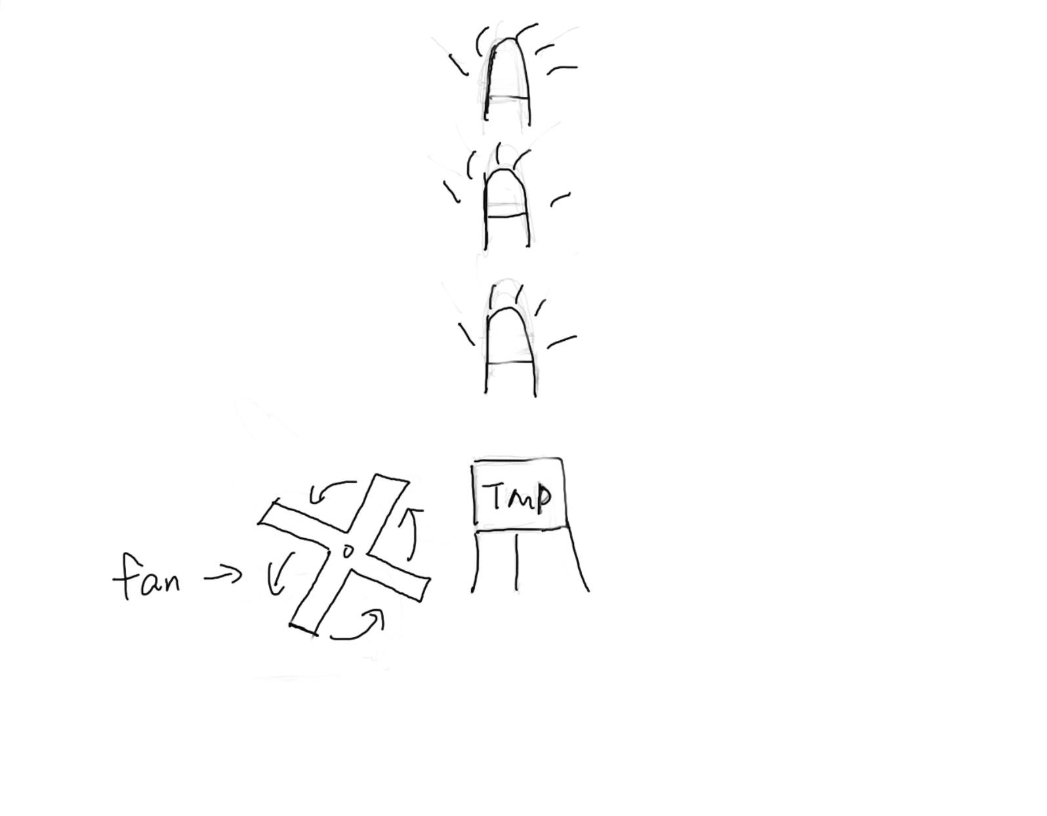

Overall of the concept

Firstly, I want to use the temperature sensor to control the lightness of light. Then I want to add a servo motor with a fan to change the temperature around the sensor. (I want to test whether the wind will change the temperature.)

Electrical Schematic

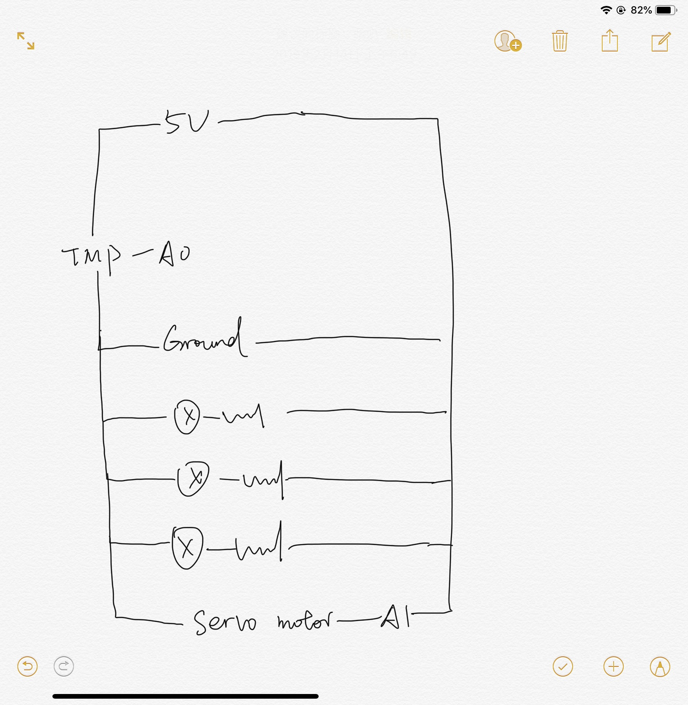

About the code

The code will connect the temperature sensor and LEDs. If the temperature goes down, the light will be turned on. The code will control the servo motor, and let the fan goes quickly or slowly.

Punch List

Learn to use the temperature sensor.

Learn to use the servo motor.

Connect the two sensor together.